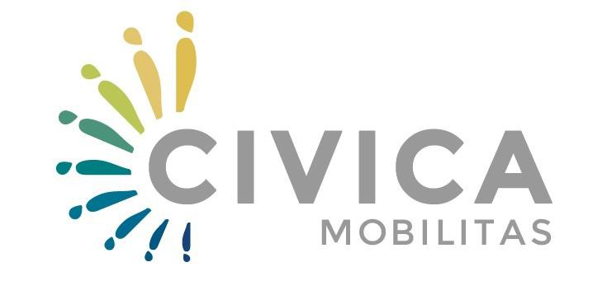

CIVICA MOBILITAS
INTERNSHIP GRANTS

CALL FOR PROPOSALS

Ref. no. CM-INR-01

Deadline: 30 June 2016, 14:00 hrs.

APPLICATION FORM

Applicant: | [Name and Surname]
Collaborator(s): | [Name of the Collaborator(s)-Civica Mobilitas’ PCO or grantee(s)]
Application No:
(to be filled by Civica Mobilitas staff)
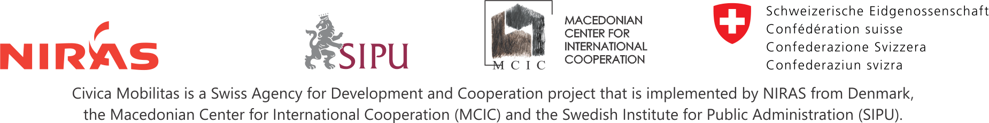

PART 1. Actors
[This part should not exceed one page. Please do not forget to enclose as annex the CV of the Applicant in Europass and Letter(s) of Interest by Collaborators]

1.1. The Applicant
PROFILE OF THE APPLICANT
Personal information
Name(s) and Surname(s)
Citizenship | Swiss |  | Macedonian |  |  |  |  | Other (what): ………….
Country, Place, Date of Birth | [country, place, dd.mm.yyyy]
Place(s) of origins | Eastern |  |  | Skopje |  |  |  |  | South-eastern
 | Pelagonia |  |  | North-eastern |  |  |  |  | Southwestern
 | Polog |  |  | Vardar |  |  |  |  | Other: ………………
Ethnic belonging | Macedonian | Turkish |  |  |  | Serbian |  |  |  | Bosnian
 | Albanian | Roma |  |  |  | Vlach |  |  |  | Other/ Mixed: ………….
Gender | Female |  | Male |  |  |  |  | Other
English Language | Understanding: [enter level(s)] |  | Speaking [enter level(s)] |  |  |  |  | Writing [enter level]
Membership in CSOs | Yes |  | Which CSOs: |  |  |  |  | No
Resume
[to include educational background, work experience and if possible, experience relevant to the civil society]
Contact data of the Applicant
Correspondence address | [Street name and number; postal code and city/town/village, country name]
Home address if different
Phone number (home) | [country code, area code and local number, e.g. +41 xxx/xxx-xxxx]
Phone number (mobile) | [e.g.+41 xx/xxx-xxxx]
E-mail address (es) | [example@example.org; example@example.com]
BlogSpot | [add link] |  |  |  | Twitter |  | [add link]
Facebook | [add link] |  |  |  | LinkedIn |  | [add link]

1.2. Collaborators
[Please add as many rows as necessary to create entries for each additional collaborator].
List of Collaborators
Collaborator 1 | [full name of the collaborator and type of grantee]
Collaborator 2
Collaborator 3

PART 2. INTERNSHIP
[This part should not exceed one page]

2.1. Internship Plan
Title
Personal motivation | [please, state the personal motivation or factors prompting to apply for internship]
Objective | [please, outline the overall objective, providing details of two or three key aspects that the internship will address]
Action | [please, provide brief overview of the activities that you plan to undertake]
Relevance | [please, briefly explain the relevance and the importance of the internship for the work plans and/or actions of the selected collaborators and describe how your internship will contribute to the Civica Mobilitas objectives and outcomes]
Collaboration | [please, briefly explain how and to what extent you will promote collaboration among CSOs from Switzerland and Macedonia, with focus on host CSO; also briefly explain how you will collaborate with other Civica Mobilitas’ grantees and with its PCO; if possible you can indicate collaboration with concrete CSOs from Switzerland]

2.2. Grant
Grant Duration | [in months]
Preferred Period | [dd/mm/yyyy-dd/mm/yyyy]
Grant Request (in CHF) | [requested budget from Civica Mobilitas]

2.3. Action Plan of the Internship
Activity / Month | 1 | 2 | 3 | 4 | 5 | 6
1.1. [Activity / Product …]
1.2. [Activity / Product …]
1.3. [Activity / Product …]

PART 3. DeCLARATION BY THE APPLICANT

The Applicant, in the context of the present Call for Proposals, Ref. No. CM-INR-01, hereby declares that he/she:
- Has read and understood the Guidelines for Applicants and instructions set there.
- The Applicant is eligible in accordance with the criteria set out under Section 3 of the Guidelines for Applicants;
- Has completed the Application Form as required;
- Has provided correct and complete data and information provided about the Applicant, if necessary, could be proved;
- Has sufficient capacity to carry out the proposed internship as described in Part 2 of this Application;
- Is willing to realise the internship in his/her full capacity i.e. 40 working hours weekly;
- Is willing to realise the internship in collaboration with Civica Mobilitas.

Signed on behalf of the Applicant
Applicant | [Name and Surname]
Signature
Place and Date

4. PART D. ANNEXES

Please provide following documents as annexes to the Application form:
Annex 1. CURRICULUM VITAE (EUROPASS FORMAT)
Annex 2. LETTER(S) OF INTEREST BY PROPOSED COLLABORATOR(S)
Annex 3. BUDGET OF THE INTERNSHIP
Annex 4. ADMINISTRATIVE AND ELIGIBILITY DOCUMENTS:
- Scanned passport(s) of the relevant pages
- Proof of proficiency in English language (if any)

https://europass.cedefop.europa.eu/en/home
Levels: A1/A2: Basic user - B1/B2: Independent user - C1/C2 Proficient user; Common European Framework of Reference for Languages: http://europass.cedefop.europa.eu/en/resources/european-language-levels-cefr. Please do not forget to enclose internationally standardised language certificate;
Full list of the grantees by type of the grant can be found at: http://www.civicamobilitas.mk/mk/civica-mobilitas/za-grantistite

